**Project Design Phase-I**

**Solution Architecture**

|  |  |
| --- | --- |
| Team ID | PNT2022TMID30639 |
| Project Name | IOT BASED SAFETY GADGET FOR CHILD MONITORING&NOTIFICATION SAFETY |
| Maximum Marks | 4 Marks |

**Solution Architecture:**

In order to connect business issues with technological solutions, solution architecture is a complicated process with numerous sub-processes. Its goals are to:

• Track down the most effective technological remedy for current business issues.

• Explain to project stakeholders the structure, traits, behaviour, and other features of the software.

• Specify the features, stages of development, and requirements for the solution.

• Offer guidelines for how the solution is created, managed, and delivered.

# FEATURES:

Development of a safety gadget for children to ensure their protection without direct monitoring of their parents. The various features involve:

* GPS
* Geo fence
* Notify alert signal

**SOLUTION:**

GPS is used to track the child's current location, and the same is continuously observed. The enrolled device will get alert messages or alerts when the device detects activities outside the specified geo fence (as specified by the parent or guardian). If any risk is felt, additional features like message recording could be performed

• GPS is used to track the child's current location, and the same is continuously observed. The enrolled device will get alert messages or alerts when the device detects activities outside the specified geo fence (as specified by the parent or guardian). If any risk is felt, additional features like message recording could be performed

# .SOLUTION ARCHITECTURE DIAGRAM:

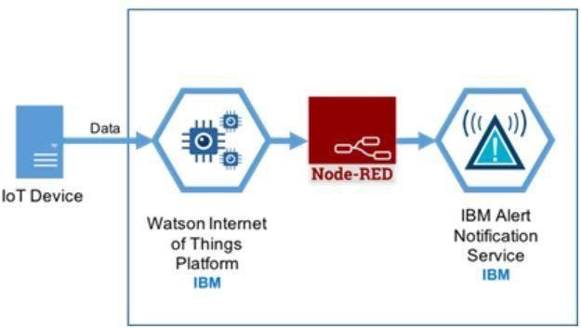

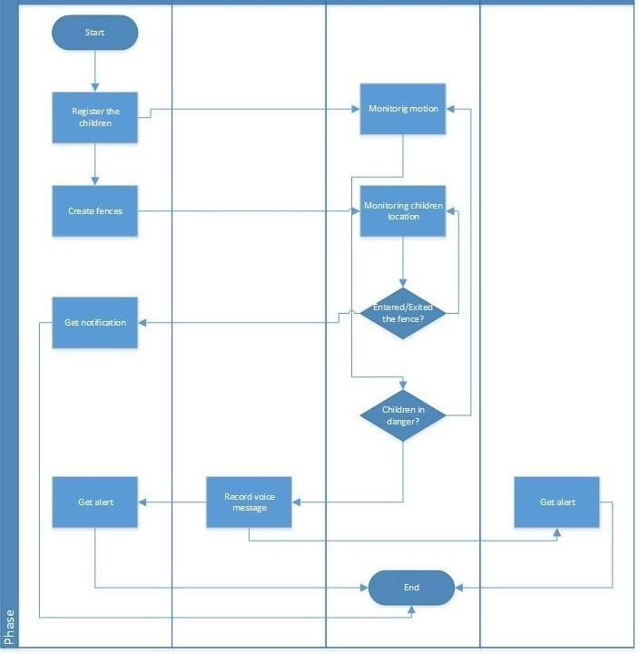

*Figure 1: Architecture and data flow of the child safety gadget system*

**Reference: https:**[**//www.ijraset.com/research-paper/wearable-safety-device-for-children**](http://www.ijraset.com/research-paper/wearable-safety-device-for-children)